Co1

EXP. 2 — QUESTION B

OPTIMUM FREQUENCY ANALYSIS

1. AIM
To identify the optimum operating frequency from the 8–12 GHz S-parameter sweep by locating the minimum magnitude of S11 and maximum magnitude of S21. To record the corresponding S-parameters, return loss and insertion loss and compare them with the values at 10 GHz.

2. SOFTWARE USED
MATLAB

3. MATLAB CODE
clc;
clear;
close all;

%% QUESTION B: OPTIMUM OPERATING FREQUENCY

% Input parameters (same as Question A)
Z0 = 50; % Reference impedance (ohms)
Zline = 55; % Assumed characteristic impedance (ohms)
L = 50e-3; % Line length (50 mm)
f0 = 10e9; % Center frequency (10 GHz)
fstart = 8e9; % Start frequency (8 GHz)
fstop = 12e9; % Stop frequency (12 GHz)
c = 3e8; % Speed of light (m/s)
loss10_dB = 1.5; % Assumed loss at 10 GHz

%% Frequency sweep
f = linspace(fstart,fstop,4001);
N = length(f);

S11 = zeros(1,N);
S21 = zeros(1,N);
S12 = zeros(1,N);
S22 = zeros(1,N);

%% Calculate S-parameters
for k = 1:N

% Frequency-dependent attenuation
alpha_dB = loss10_dB*sqrt(f(k)/f0);
alpha = alpha_dB*log(10)/20;

% Propagation constant
beta = 2*pi*f(k)/c;
gamma = alpha + 1j*beta;

% ABCD parameters of lossy transmission line
A = cosh(gamma*L);
B = Zline*sinh(gamma*L);
C = sinh(gamma*L)/Zline;
D = cosh(gamma*L);

% ABCD to S-parameters
den = A + B/Z0 + C*Z0 + D;

S11(k) = (A+B/Z0-C*Z0-D)/den;
S21(k) = 2/den;
S12(k) = 2*(A*D-B*C)/den;
S22(k) = (-A+B/Z0-C*Z0+D)/den;
end

%% Magnitudes in dB
S11_dB = 20*log10(max(abs(S11),eps));
S21_dB = 20*log10(max(abs(S21),eps));

%% Find optimum frequencies
% Minimum input reflection
[~,idx_min] = min(abs(S11));

% Maximum forward transmission
[~,idx_max] = max(abs(S21));

f_min_S11 = f(idx_min);
f_max_S21 = f(idx_max);

%% Values at 10 GHz
[~,idx10] = min(abs(f-f0));

RL_10 = -S11_dB(idx10);
IL_10 = -S21_dB(idx10);

%% Values at optimum matching frequency
S11_best = S11(idx_min);
S21_at_match = S21(idx_min);

RL_best = -S11_dB(idx_min);
IL_at_match = -S21_dB(idx_min);

%% Values at optimum transmission frequency
S11_at_trans = S11(idx_max);
S21_best = S21(idx_max);

RL_at_trans = -S11_dB(idx_max);
IL_best = -S21_dB(idx_max);

%% Display results
fprintf('\n===== QUESTION B: OPTIMUM FREQUENCY =====\n');

fprintf('\nAt 10 GHz:\n');
fprintf('|S11| = %.4f dB\n',S11_dB(idx10));
fprintf('|S21| = %.4f dB\n',S21_dB(idx10));
fprintf('Return loss = %.4f dB\n',RL_10);
fprintf('Insertion loss = %.4f dB\n',IL_10);

fprintf('\nMinimum |S11|:\n');
fprintf('Optimum matching frequency = %.4f GHz\n',...
f_min_S11/1e9);
fprintf('S11 magnitude = %.4f dB\n',S11_dB(idx_min));
fprintf('S21 magnitude = %.4f dB\n',S21_dB(idx_min));
fprintf('Return loss = %.4f dB\n',RL_best);
fprintf('Insertion loss = %.4f dB\n',IL_at_match);

fprintf('\nMaximum |S21|:\n');
fprintf('Optimum transmission frequency = %.4f GHz\n',...
f_max_S21/1e9);
fprintf('S11 magnitude = %.4f dB\n',S11_dB(idx_max));
fprintf('S21 magnitude = %.4f dB\n',S21_dB(idx_max));
fprintf('Return loss = %.4f dB\n',RL_at_trans);
fprintf('Insertion loss = %.4f dB\n',IL_best);

%% Plot results and mark optimum frequencies
figure('Name','Question B: Optimum Frequency',...
'NumberTitle','off');

subplot(2,1,1);
plot(f/1e9,S11_dB,'LineWidth',1.8);
hold on;
plot(f_min_S11/1e9,S11_dB(idx_min),'ro',...
'MarkerFaceColor','r');
xline(10,'--k','10 GHz');
grid on;
xlabel('Frequency (GHz)');
ylabel('|S11| (dB)');
title('Minimum Reflection Frequency');

subplot(2,1,2);
plot(f/1e9,S21_dB,'LineWidth',1.8);
hold on;
plot(f_max_S21/1e9,S21_dB(idx_max),'ro',...
'MarkerFaceColor','r');
xline(10,'--k','10 GHz');
grid on;
xlabel('Frequency (GHz)');
ylabel('|S21| (dB)');
title('Maximum Transmission Frequency');

sgtitle('Optimum Frequency Analysis: 8-12 GHz');

4. OUTPUT
Insert the MATLAB output screenshots showing the S-parameter curves and the optimum frequency.
Record the following:
- Optimum frequency
- S11 at the optimum frequency
- S21 at the optimum frequency
- Return loss at the optimum frequency
- Insertion loss at the optimum frequency
- Comparison of these values with those at 10 GHz

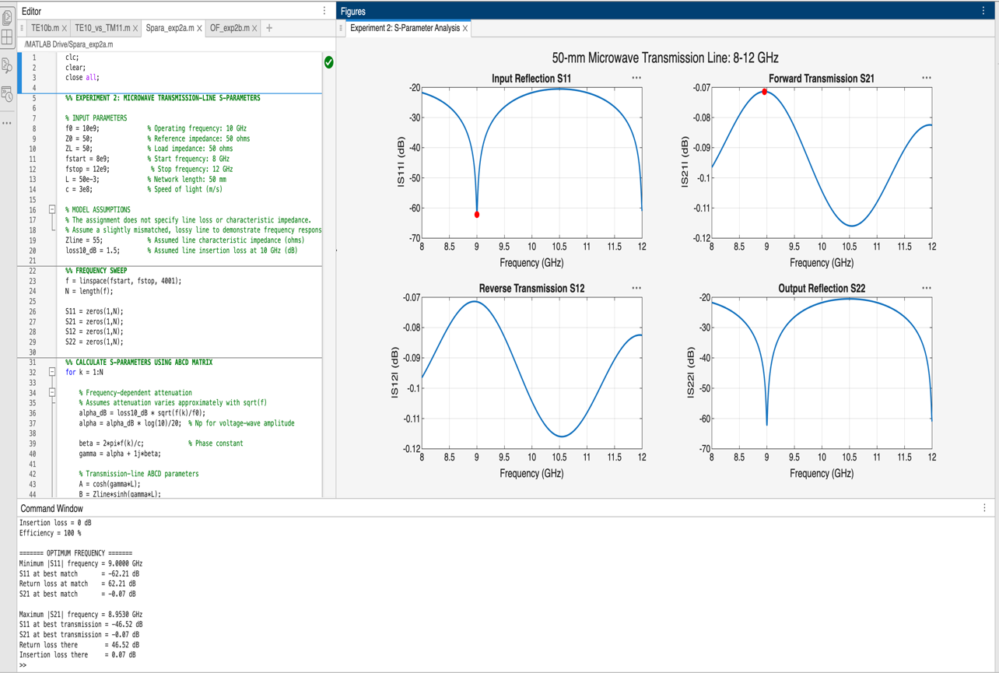

5. RESULT
The optimum operating frequency was identified from the simulated S-parameter sweep by determining the minimum |S11| and maximum |S21|. The return loss and insertion loss at this frequency were compared with their values at 10 GHz to evaluate the matching and transmission performance of the network.

